**Title title title title (*Genus species*) title**

(Bolded, Times New Roman; 14pt; Line spacing: 1,15; Align left)

**Representing Author’s Name SURNAME1**, Author Name SURNAME1, Author Name SURNAME2 (Representing author bolded an underlined, Times New Roman; 12pt; Line spacing: 1,15; Leave a space between paragraphs, Align left)

***1*** *Institution Name, City, COUNTRY (Italics, Times New Roman; 12pt; Line spacing: 1,15, Align left)*

***2*** *Institution Name, City, COUNTRY*

Correspondence: [user@mail.com](mailto:user@mail.com) (Times New Roman; 12pt; Line spacing: 1,15; Leave a space between paragraphs, Align left)

***Abstract:*** *A brief summary of your study, ~50-60 words; Italics; Times**New Roman; 10pt; Line spacing: 1,15;**Leave a space between paragraphs. Start the text after the bolded “****Abstract:****” title on the same line. Justified.*

**Keywords:** 3-5keywords should be givenTimesNew Roman; 10pt; Line spacing: 1,15; Leave a space between paragraphs.Start the text after the bolded “**Keywords:**” title on the same line. Justified.

**Introduction:** Short information about the study material and/or region. The importance of the study material/region can be explained. Objectives of the study should be given at the end of the introduction section. TimesNew Roman; 10pt; Line spacing: 1,15; Leave a space between paragraphs.Start the text after the bolded “**Introduction:**” title on the same line. Justified.

**Material & Methods:** Brief explanation of the material(s), method(s), equation(s) and software(s) used in the study should be given. TimesNew Roman; 10pt; Line spacing: 1,15; Leave a space between paragraphs.Start the text after the bolded “**Material & Methods:**” title on the same line. Justified.

**Results & Discussion:** The general outline of the results of the study should be explained. Authors can combine their results with the discussion. High quality Figure(s) (JPEG, PNG, TIFF) and/or graph(s) and/or table(s) can be added in this section. Maximum width for an image (or grouped images) and/or table is 16 cm. Justified

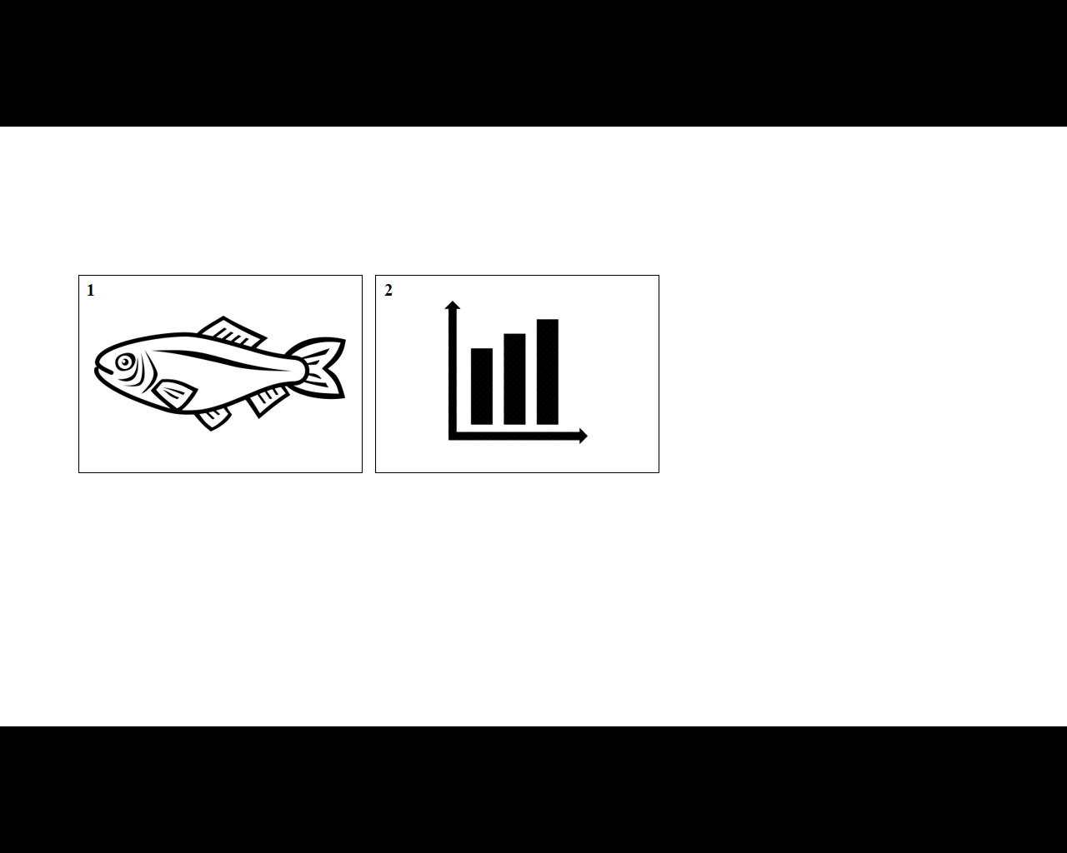

**Figure 1:** Brief explanation of the figure (Under the figure, Align Left, TimesNew Roman; 10pt; Line spacing: 1,15; Leave a space between paragraphs.)

**Figure 2:** Brief explanation of the figure (Under the figure, Align Left TimesNew Roman; 10pt; Line spacing: 1,15; Leave a space between paragraphs.)

**Table 1:** Brief explanation of the Table (Over the table, Align left TimesNew Roman; 10pt)

|  |  |  |
| --- | --- | --- |
|  | **A** | **B** |
| **1** | x | k |
| **2** | y | l |
| **3** | z | m |

**Acknowledgements:** Authors can mention their acknowledgements here. TimesNew Roman; 10pt; Line spacing: 1,15; Leave a space between paragraphs.Start the text after the bolded “**Acknowledgements:**” title on the same line. Justified.

**References** (Optional) Authors can list their references cited in their abstract. TimesNew Roman; 10pt; Line spacing: 1,15; Leave a space between paragraphs.Justified.

Citation in the text: “…. previous data (Surname, 2012) or (Surname & Surname, 2012) or (Surname et al., 2012)….”

For Articles:

Surname, N., Surname, N., 2012. Title of the study. *Journal’s name abbreviation*, Vol(Issue):Page-Page.

For articles with 4 or more authors:

Surname, N., et al., 2012. Title of the study. *Journal’s name abbreviation*, Vol(Issue):Page-Page.

For Books:

Surname, N., Surname, N., 2012. *Title of the book*. Publisher, ISBN.

For chapter in a book:

Surname, N., Surname, N., 2012. Title of the chapter. In: *Title of the book* (Surname, N., - Ed). Publisher, ISBN.

For Thesis:

Surname, N., 2012. *Title of the study*. Name of the Institution, PhD/MSc thesis.

For symposium proceedings:

Surname, N., Surname, N., 2012. Title of the study. *Title of the symposium*, Country, Page-Page.

|  |  |
| --- | --- |
| **PLEASE SELECT YOUR**  **PREFERENCE (X)** | **( ) POSTER PRESENTATION** |
| **( ) ORAL PRESENTATION** |

**IMPORTANT NOTES**

* Only **.doc** or **.docx** are the acceptable file formats.
* Please **send** your abstract/full-paper to [aquabiotech@istanbul.edu.tr](mailto:aquabiotech@istanbul.edu.tr)
* Please provide the filled **registration form** file with your abstract/full-paper submission.
* Submitted abstracts/full-papers will be evaluated by experts in the field. Revisions (if required) will be sent you via e-mail. After reviewing stage, you will be informed about the final decision on your study (acceptance or rejection) via e-mail.
* Total time for oral presentations was determined as **15 minutes** (including few questions).
* Please provide a **.ppt** or **.pptx** file for your oral presentation, before the beginning of your session.
* Full papers should be prepared as **2 or 3** pages.
* The official language of the symposium is **English**.
* Acceptable poster size is **60 cmX84 cm**.

|  |  |  |
| --- | --- | --- |
| **Please select the field of your study (X)** | ( ) | Blue biotechnology |
| ( ) | Biotechnology applications |
| ( ) | Biotechnology in aquaculture |
| ( ) | Bioremediation and biodegradation |
| ( ) | Industrial and manufacturing biotechnology |
| ( ) | Algal biotechnology |
| ( ) | Aquatic metagenomics |
| ( ) | Natural products from aquatic bioresources |
| ( ) | Biosensors for aquatic applications |
| ( ) | Recombinant DNA technology |
| ( ) | Vaccine development and delivery systems |
| ( ) | Probiotics |
| ( ) | Gene therapy |
| ( ) | Detection kits |
| ( ) | Cryopreservation |
| ( ) | Reproductive biotechnology |
| ( ) | Gamet quality |
| ( ) | Germ cells |
| ( ) | Biotechnology applications in seafood |

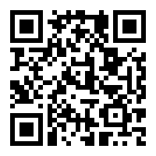

For more information: visit <https://aquabiotech.istanbul.edu.tr>

Follow us on [twitter](https://twitter.com/AquaBioTech2020) and [instagram](https://www.instagram.com/aquabiotech2020/) for updates.

#AquaBiotech2020