TITLE (Arial, Bold, 12 pt, centered)
Author’s Name and Surname¹, Author’s Name and Surname² (Arial, 11 pt, centered)
¹Affiliation, E-mail (Arial, 10 pt, centered)
²Affiliation, E-mail

GUIDELINE for AUTHORS
Conference uses a double-blind review, which means that both reviewers and author identities are conceived from the reviewers, and vice versa, throughout the review process. To facilitate this, authors need to ensure that their paper s are prepared in a way that does not give away their identity and their names must not appear anywhere in the extended abstract. The submitted paper must not have been published anywhere before and should not be entered into the evaluation process for publication elsewhere. The scientific responsibility of the paper belongs to the author.
The paper written in font Arial, single line spacing and 10 font size. The paper should contain a minimum of 1500 words and a maximum of 2500 words (max. 10 pages). Paper can contain figures, tables and/or images which are not included in the word count. The references are not included in the word count as well. Page format should be A4 page size with margins 2 cm wide from the top, 1,5 cm wide from the right left and bottom. Supporting figures, tables and images of the results (no more than two figures and two tables) may be included in the extended abstract. All the tables, images and figures should be centered. Figures and images should be numbered (Figure 1) and figure headers should be placed under the figure or image; as for the tables, they should also be numbered (Table 1) and the table header should be placed at the top.. Pages should not be numbered.
The paper must contain the following sections: abstract, keywords, introduction, method, findings, conclusion, and references.

Abstract (Arial, Bold, 11 pt)
Abstract should written with 10 font size, Arial, single line spacing. This section sholud be include aim of study. Summarize in this section objective, method and findings. Abstract should not exceed 150 words.
*: As you know your abstract published in FL2018 abstract book. Please make sure your abstract is not exactly the same as the published abstract.

Keywords: This section should contain maximum 3 words separated by commas.

- INTRODUCTION
The introduction section should present the scope and objective of the paper and state the problem, briefly review the pertinent literature, describe the methods, and provide an overview of the main results of the work.

- METHOD
The method must be clearly stated and described in sufficient detail and with sufficient references.

- FINDINGS
The findings and arguments of the work should be explicitly described and illustrated. Supporting figures (Figure 1) and tables (Table 1) of the results may be included in the extended abstract.

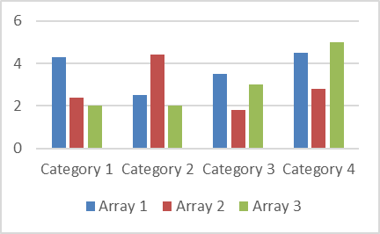
Figure 1: Title (Caption Style)

Table 1: Title (Caption Style)
Sample text | Sample text | Sample text
Sample text | Sample text | Sample text
Sample text | Sample text | Sample text

- CONCLUSIONS
Discussion and Conclusions should include the principles and generalizations inferred from the results, any exceptions to, or problems with these principles and generalizations, theoretical and/or practical implications of the work, and recommendations.

- REFERENCES
References should be listed in alphabetical order using References Style and presented in a format according to the American Psychological Association, Sixth Edition: http://www.apastyle.org/manual/

Corresponding Author (should be signed with star).

